Lubensky Lab Vertex Model Tutorial 2 V2.0
Last Updated By: Avik Mondal
03-01-2020

This tutorial assumes that you are already familiar with how to run the base code of the vertex model, and you are ready to start making major changes. For the rest of this tutorial we are going to make a series of new files. If you get stuck you can see the correct implementation and files labeled *Tutorial2 .

For this tutorial we will implement a common variant of the energy function in which
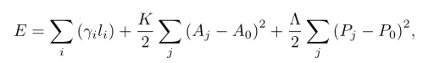
where P is the perimeter. This energy leads to a force function where the edge tension is modified to be
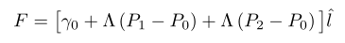
Our goal is to modify the vertex model to use this energy form instead. We could just go in and change the code we have already written, and this would be faster in the short run, but it would be annoying when we had to change it all back latter, or mess up someone else’s code. Instead we will cordon off our little change into its own subclass so we can leave the base class pristine and switch back and forth easily.

In order to implement this new class we will first list all the changes we need to make.
- Add global variables P0 and Lambda
- Add P0 to the cell class (in case we want each cell to have a different value)
- update the edge class function get tension magnitude
- Add the new cell and edge subclasses to the tissue subclass
- change our main file to make a perimeter variant tissue instead of a base class tissue

Quest 0: Make your own Main file
Everyone in the group should have their own Main file (in fact if you have multiple vertex models going at once you should have multiple main files). This stops us from all over writing each other in the base code. In the CPP Code folder make a new main file that is simply a copy of the old one and name it MainPerim.cpp. Make a new project that includes all of the same header and cpp files as normal, but has your main file instead of MainBase.cpp. We will continue to add files to this project throughout the tutorial.

Quest 0.5: Some notes on making new projects in Microsoft Visual Studio.

There are a few basics you should be aware of before you jump into the details of the code. Microsoft Visual Studios has a few unusual features that are strange even for the experienced programmer. For one thing, it has the concept of “Solutions”, which can contain many different “Project” (read: classes and main files). Solutions are meant to be containers to organize related projects. The vertex model code exists inside its own Solution, initially alone. Projects are probably more of what coders are used to. A project will contain the classes made by the coder and will probably have one Main function each. I recommend making a new Project (name it PerimVertex or something like that).

To “Make a new project that includes all of the same header and cpp files as normal. . .”, you can look at the right side of the Microsoft Visual Studios window, to the “Solution Explorer” window.

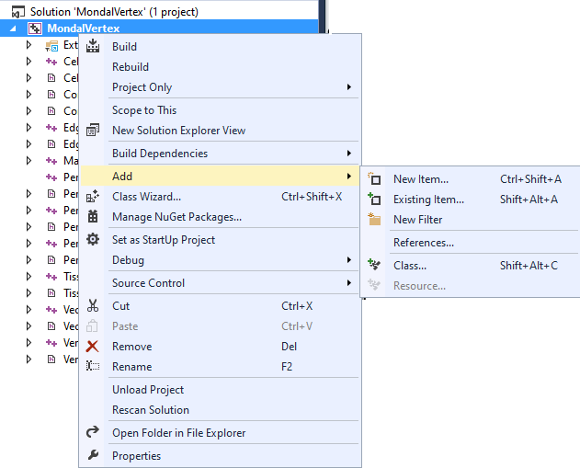

Right click on your new project to add the old header and cpp files. Under the “Add” section, select “Existing Item..” to add the files that exist in “VertexModel.” This way, you can leave all the files in their existing folders and just tell the new project where they live.

Another important thing to note. Microsoft Visual Studios looks at one Project at a time. That means that even if you have a Solution open with multiple Projects, you have to select the Project you want it to pay attention to.

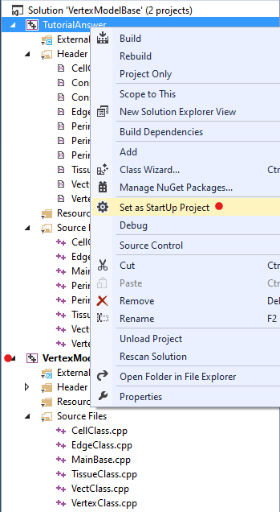

Notice that VertexModelBase is emboldened. This means Microsoft Visual Studio is looking at it (when you want to compile a project, it will compile VertexModelBase. To tell the program to look at TutorialAnswer, right click and select “Set as StartUp Project.” This is an important step particularly when you are ready to compile your new MainPerim function.

Quest 1: Add global variables
Start by making copy of the initialization file. Add the variables under the Global parameters and give them values. Check that your “Global Parameters” numbers looks similar to the ones printed here. Especially important are the values for GAMMA, LAMBDA, and P0 (in particular, their relative magnitudes are important).

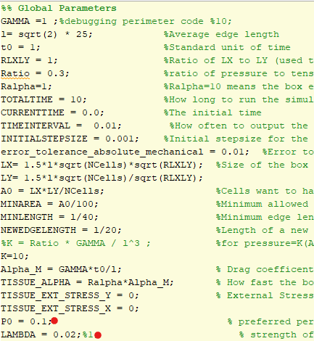

Under “export to a text file” add print statements so that our new global variables are printed with the rest.
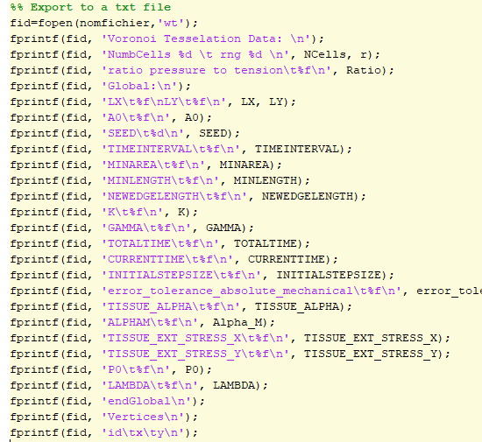
Name your tissue and run the file. You should see a new text file be created. Open it up and check that your new global variables were recorded. Global variables can be recorded in any order as long as they come between the line “global:” and “endGlobal”.

We are ready to start making some perimeter specific files. First make a new ConstantsPerim.h file to hold your new global constants, (since this step is not enlightening I did it for you). Add this file to your project (under Header Files -> add existing item). In your main file make sure to include the new constants file.
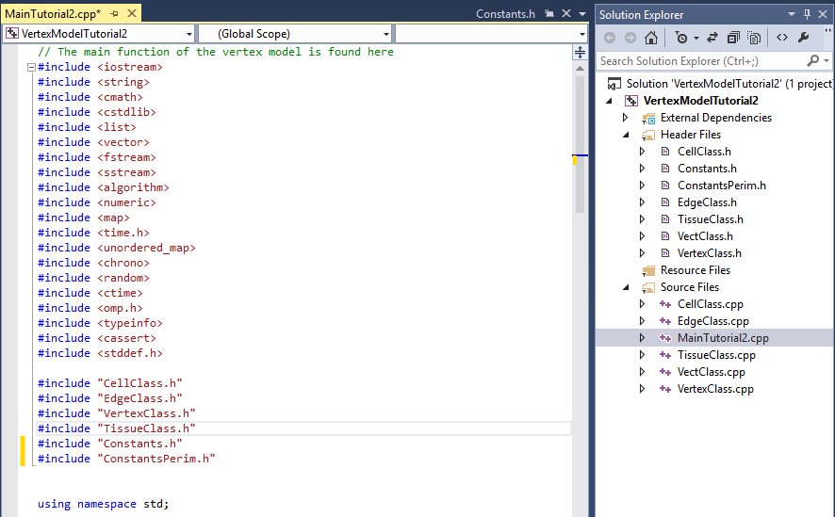

In your main file declare your new variables under the long list of other global variable
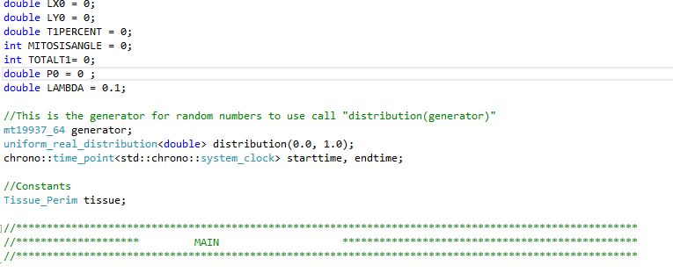

Global variables are read in in the tissue object function HelperReadInputData_SetGlobalValues.
We want to change this function so we need to make a subclass of the tissue class that overwrites the normal behavior. (If you don’t know how subclasses work go take half a day and read up on them. There are plenty of resources online that will walk you through creating a simple class and subclass. It is worth going to Deitel’s book in the office and reading the chapter on Inheritance. This is a very general concept in object oriented programming that is worth understanding both in general and for specific programming in C++.)

I have made the header file for you. When you make a new subclass just follow this template. There are a few key features to note:
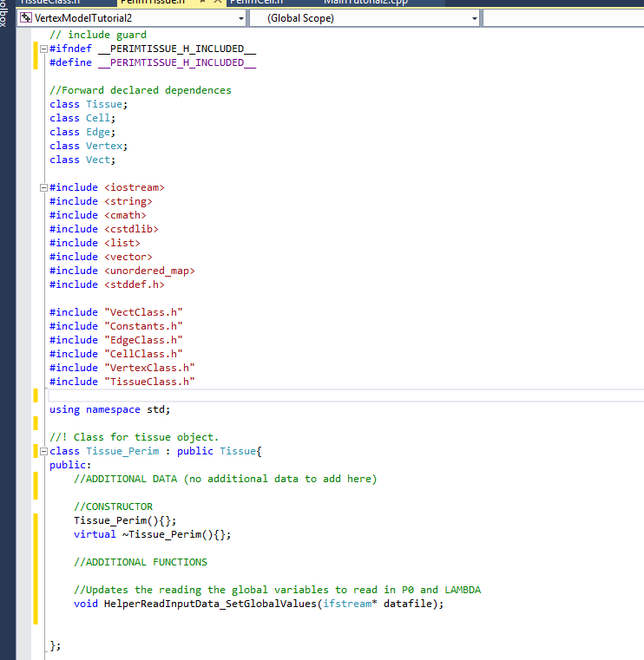
always include constructors/destructors for housekeeping
this defines our new subclass
make sure that the include guard has the exact
same name as the file

Now we can write new behavior for the setting the global values in our subclass. Make a new file called PerimTissue.cpp and include it in your project. Add our favorite libraries to the top
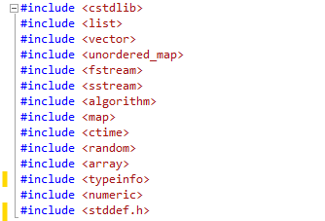

In order to set the constants we need to include the constant headers as well as the tissue class header and our subclass header. Add these now. You should have a file that looks like:

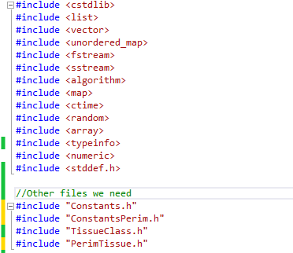

Now we can add some new global variables! We want to copy the code for reading in the existing variables plus add two more of our own. Copy the HelperReadInputData_SetGlobalValues function from tissueClass.cpp into PerimTissue.cpp. You should now have a file that looks like:
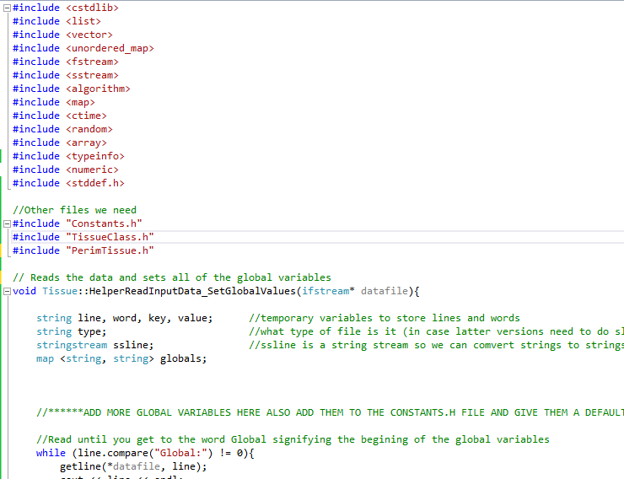

We are making a Tissue_Perim function not a tissue function so change the name after “void” to reflect this.

Now go to the end of the function and add our two new global variables by following the same template as the rest of the global variables. If you are stuck look at the PerimTissue_Tutorial2.cpp file. This ends our quest to add new global variables!

Quest 2: Add P0 to the cell class (in case we want each cell to have a different value)
This has been done for you take a look at the header file and note that it follows the same template that we used for declaring the Tissue_Perim subclass. Note that since we are not adding any new functions to the Cell_Perim subclass we don’t need to make a .cpp file for it.

Quest 3: update the edge class function “get tension magnitude”
Once again I have make the header file for you. There is an outline of the PerimEdge.cpp file for you. It is very important to remember that the data P0 is ONLY part of the subclass Cell_Perim and not the base class. This means that

(*cell1).GetPerimeter()- (*cell1).P0

will return an error because the cell class has no data member P0. Instead first create a pointer to a Cell_Perim class object by

Cell_Perim* c1 = dynamic_cast<Cell_Perim*>(cell1);

now
(*c1).GetPerimeter() - (*c1).P0

will work just fine. Try and write this function on your own. Remember that if you get stuck you can peek at the answer in PerimEdge_tutorial2.cpp.

Quest 4: Add the new cell and edge subclasses to the tissue subclass
We have made a new PerimTissue subclass and made it read in our new global variables, but right now it doesn’t know anything about our new edge and cell subclasses. When we create the tissue we want to be sure to make PerimEdges and PerimCells and not base class objects. In order to change this we first need to figure out where these objects are created in the base class. The best way to do this is to walk through the code function by function until we find what we need. Go to your main file and do a line by line walk through until you find the first function that takes you out of main.

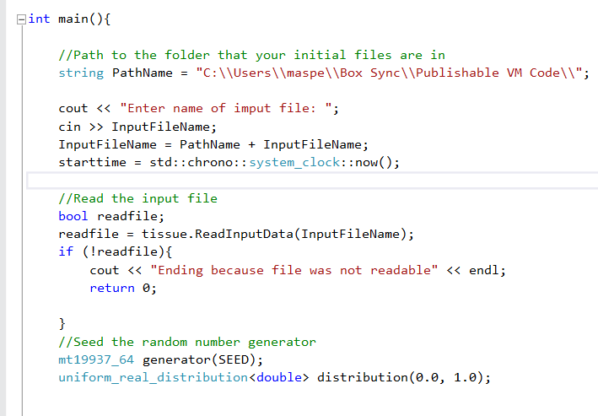
yes!
no
no
no
no
no

Step into this function
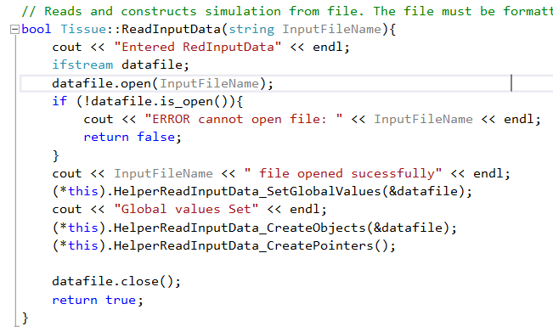

We have already updated the HelperRedInputData_SetGlobalValues function so lets take a look at the next function HelperReadInputData_CreateObjects. As you read through this function you should find that it creates the edge and cell objects.
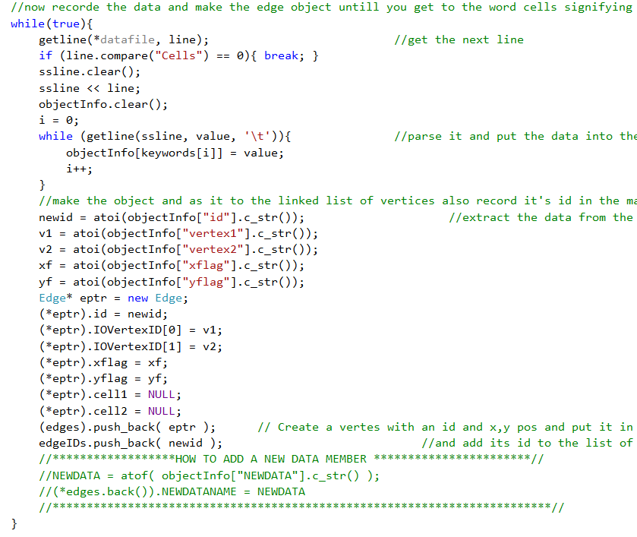

We want to override this function to have it create Perim edges and cells. Copy the function from the base class into your PerimTissue class and update the lines that create the edge and cell objects to create the subclass objects. Remember to
1: Add the function HelperReadInputData_CreateObjects to the PerimTissue.h header file.
2: Include PerimEdge.h and PerimCell.h in the PerimTissue.h file
3: Make sure the function is declared as Tissue_Perim:: HelperReadInputData_CreateObjects
4. Give an initial value to cell.P0 when you create the cells

Update: 4/5/20
One potential issue can arise when T1’s or Mitosis occurs in the packing. When these topological changes occur, new edges and vertices are created. In the case of the above potential, an important thing that needs to get changed is the CreateEdge function. CreateEdges adds to the edge list that is part of the Tissue class. If you want these new edges to use the correct GetTension() functions, you need to make sure they are of the correct type (read: new subclass of Edge) of Edge. All you need to do here is update the instantiation of new edge objects. This is an issue that I (Avik) ran into and it wasn’t in the original tutorial – unfortunately, I don’t have a lot of time to add it to this file and so I’m going to point you in the direction of my old code (which will hopefully be in an accessible place) to look at the AGPerimTissue class.

Quest 5: change our main file to make a perimeter variant tissue instead of a base class tissue

First add our new header files to the includes section of the main file, and change the tissue to a perimeter tissue.
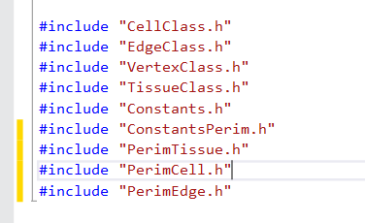
...
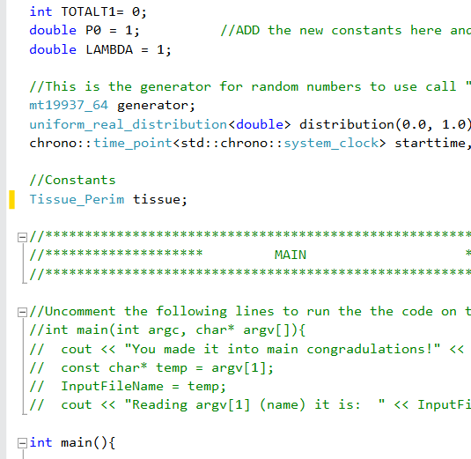

We have now crossed everything off our list so we should be ready to go! Try building your new project. Make sure your new project is labelled as the “StartUp Project.” Make sure your project links correctly to all the necessary header and cpp files. If there are build errors try and fix them yourself. If you get stuck take a peak at the solution I have.

Bonus Quest: See how this new energy function differs from our usual function.
Using the same seed make two initial text files, one for the base class and one for the perimeter subclass. Run both files using the base class and perimeter class vertex models, and compare the results. Notice how the fact that we took time to make a subclass model allows us to do this comparison. If we had just edited the base class files we would have to edit them all back to do this comparison. Making subclasses is more work up front but it will really save you time in the long run.

Next Steps (updated by Avik): Understanding the intricacies of this perimeter model and more of how to use the perimeter model:
The reason there is a v2.0 of this tutorial is because the new terms we add to this model are extremely non-trivial. Before carrying onto do research, see the next tutorial to understand a little bit more about the details of the vertex model. This is next part of the tutorial is optional, because you’ll probably learn all of it as you continue further doing research, but if you have some time, it could be worth checking out.

GO DO RESEARCH!

